# Lesson 1 – Selecting and Editing Features

## DESCRIPTION

In this lesson, as well as in further lessons, different icons and font styles guide you and help you get the necessary information in order to complete these lessons.

Important general information



 Information on the current chapter

Workflow (what you should do)



Italic Italic letters show you the *command* name and *default* settings

**Bold** Bold letters show you the active command name

SMALL CAPS Mouse control movements

1. General numeration

Numeration for programme work steps



Text Input text to type in

## CREATING A NEW PROJECT



1. Start ArcGIS Pro and sign in using the ArcGIS Enterprise named user account (see Lesson 0). ArcGIS Pro automatically opens the start page. Here, you find options to either open an existing project or create a project using one of the available templates. Project templates are listed under the heading New Project.

* If you've created a project before, it'll be listed under the heading Recent Projects.

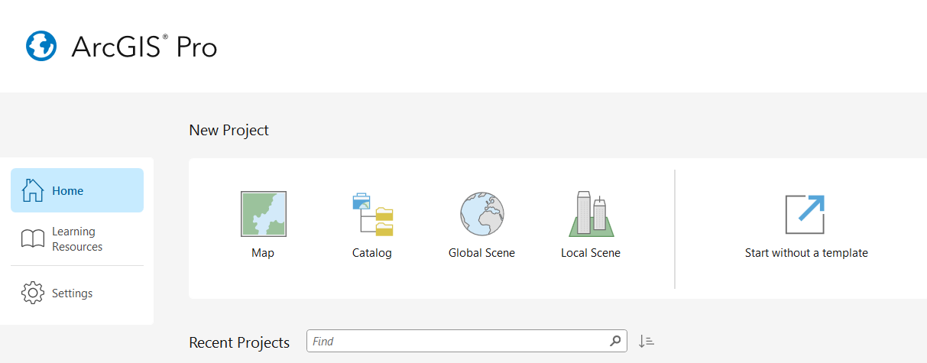

1. CLICK Map. The **New Project** dialog box opens.
2. On the dialog box*, Type in* a reasonable project name. By default, projects are created in the *<User Documents>\ArcGIS\Projects* folder. Save the project in a different location where You have editing permissions and where You will find the project files for following lessons. When using TUM-PC, it is recommended to save it on Your own personal drive (the one with Your TUM ID). CLICK the *Browse* button Browse and browse to the folder you want.
3. CLICK OK. A default 2D map opens with your project.
4. You see two standard raster Esri map layers we do not need for this lesson. Please remove one by RIGHTCLICKING on the layer *World Topographic Map* in the Contents pane and CLICKING *Remove*. Repeat this for the *World Hillshade* layer.

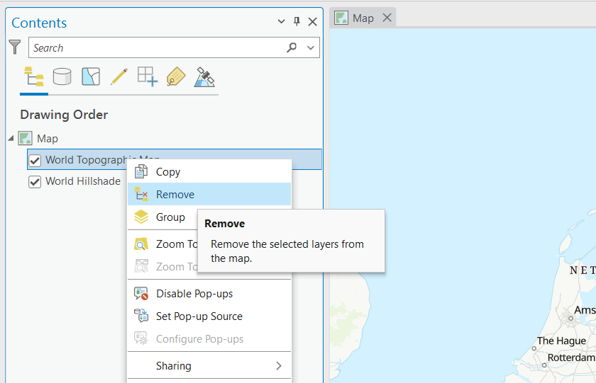

1. On the ArcGIS Pro ribbon, CLICK the *View* tab. In the *Windows* group, CLICK *Catalog view* . If the *Contents* pane is not open on the left side, CLICK on *Contents* to open this pane.

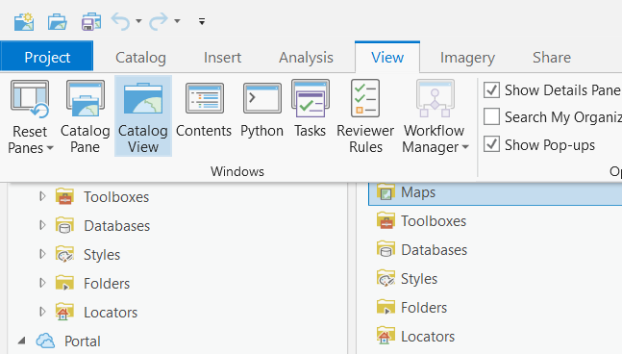

1. The *Contents* and *Catalog* panes are now open (if they were not open before).

### Connecting a Folder to the Project

* Switch to the Catalog tab.
* RIGHTCLICK on *Folders* and CLICK on *Add Folder Connection.*

1. Browse to the folder in which You downloaded the *Data Students.gdb* geodatabase within the **Add Folder Connection** dialog box.
2. CLICK on your folder to select it, and confirm by CLICKING *OK*.

* If a shared folder becomes unavailable on the network, ArcGIS Pro won't be able to access its contents. A red exclamation mark Attentionappears on the folder's icon, indicating that the connection is broken.

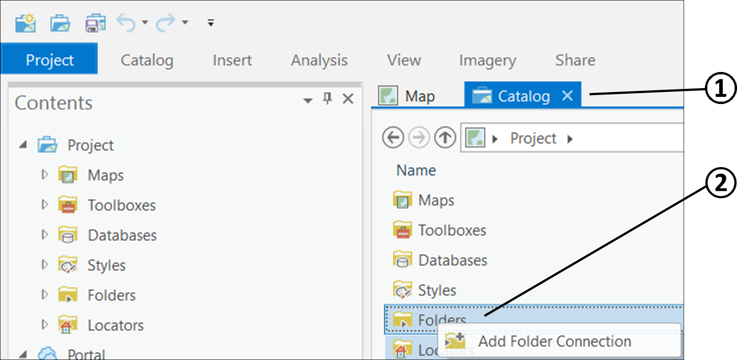

### Add a Database

* Switch to the Catalog tab (if not already happened).
* RIGHTCLICK on *Databases* to and CLICK on *Add Database.*

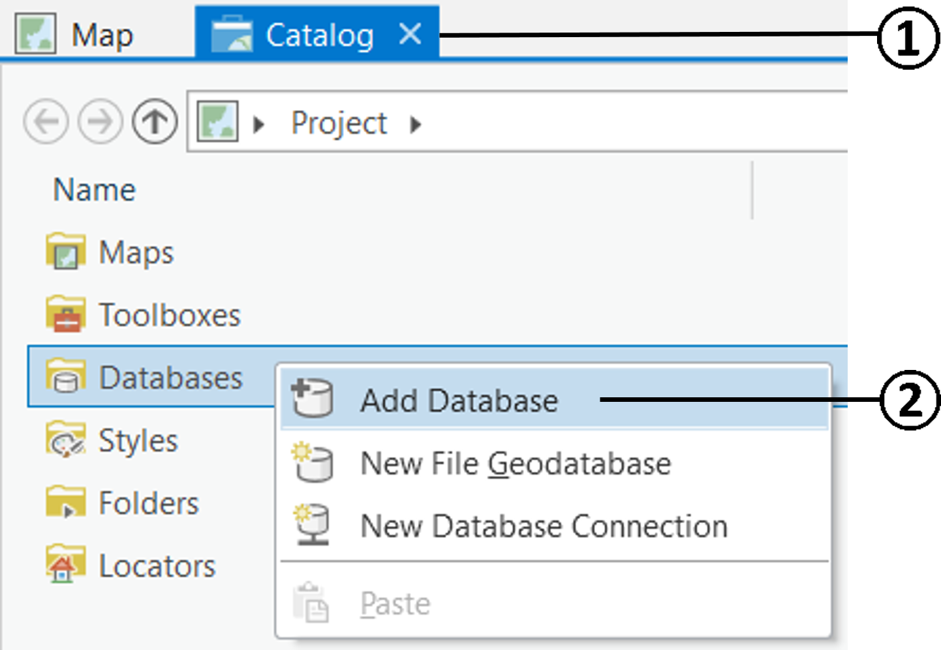

1. Browse to the folder in which You downloaded the *Data Students.gdb* geodatabase within the **Add Database** dialog box.
2. CLICK on the Database *Data Students.gdb* to select it, and confirm by CLICKING *OK*.

* The data must be copied to Your own web disk or local disk space. Otherwise You cannot edit the “*Data Students*” geodatabase.

## ADDING A LAYER TO THE MAP

A layer references a dataset that is stored in a geodatabase, a shapefile, a raster, x,y data tables, etc. You can add one of these datasets, an existing layer that is already defined from ArcGIS Online (\*.lyrx), or create a new layer.

Workflow_icon

1. Make sure the ***Map*** view is your active view. You should see the empty map again.

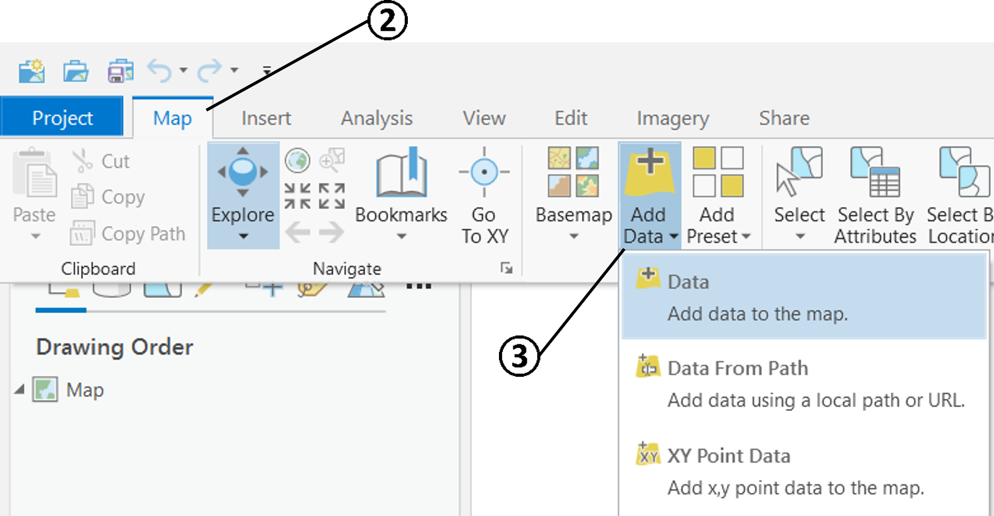

* Switch to the *Map* tab.
* In the Layer group, CLICK *Add Data* Add Data, and *Data.*

1. Browse to your connected Folder that contains the data. DOUBLECLICK on the Database *Data Students.gdb*. Select the feature classes *buildings* and *roads* (press Ctrl/Strg button to select multiple) and confirm with *OK*.

This is what Your **Map** view should look like (colours are not crucial yet):

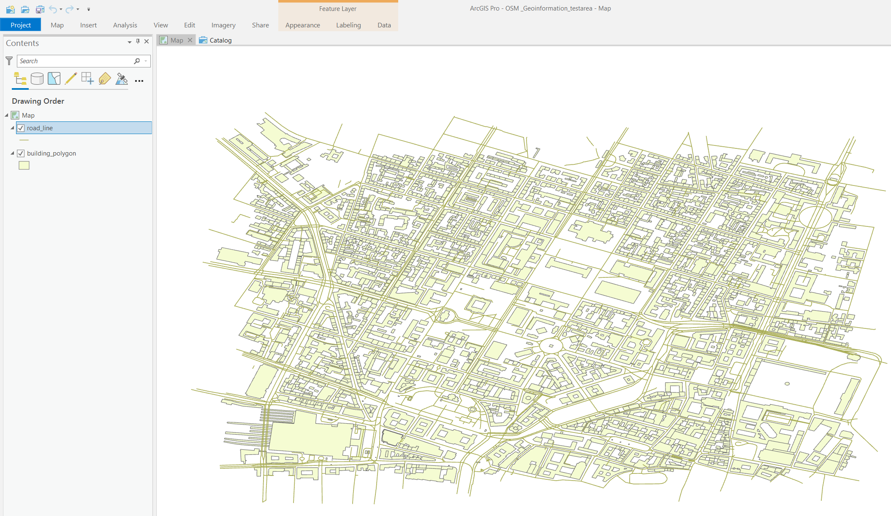

## ADD AN IMAGE LAYER TO THE MAP

ArcGIS Pro allows you to manage, analyze, visualize, and share your raster data. This raster functionality is contextual, which means that the options presented depend on the type of data you have selected. When you work with images, the options on the ribbon will be applied to the raster layers you have selected in the Contents pane. When you select an image in the Contents pane, the *Appearance* and *Data* tabs appear under the Raster Layer contextual tab on the ribbon. There are other core tabs, such as the *Imagery* tab, that are always available.

* Add the raster image *orthophoto.tiff* to your map from the Data Students folder in the same way as in 1.3.
* After adding the image, deactivate the layer’s visibility by unchecking the box next to the layer’s name on the *Contents* pane. The orthophoto is not used yet for the following tasks.

## USING POP-UPS IN ArcGIS Pro

When displaying feature layers in a map or scene, you can identify attribute information about a particular feature by opening a pop-up. Use the Explore tool Explore Tool to click a feature, or drag a box while pressing the CTRL key to identify multiple features. The Pop-up pane displays a list of identified features, grouped by layer, and a formatted list of attributes.

* Your task is to explore the cafés around the TUM by using the Pop-up dialog box.

1. Add the layer *cafes* to the map contents in the same way as in 1.3.
2. CLICK directly on the point feature on the map to see attribute details.
3. Try the Pop-up information of other layers on the map to get a feeling for the exercise geodata.

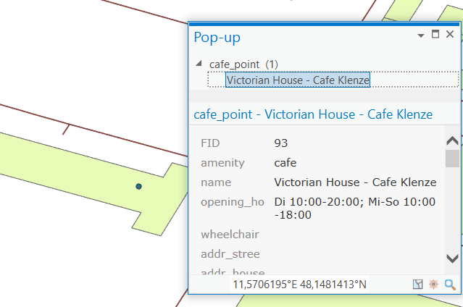

## SELECTING FEATURES INTERACTIVELY

Interactive feature selection involves clicking a single feature in the view or digitizing a shape to select a set of features. Selecting features allows you to highlight and choose a subset of features on your map to use in subsequent exploration or analysis of your data.

* Select first the Old Pinakothek and some surrounding buildings before selecting all TUM building parts as a group. It is recommended to make the buildings layer visible only, by unchecking the boxes next to all other layer names on the *Contents* pane.
* CLICK to open the *Map* tab.
* CLICK *Select* *.*

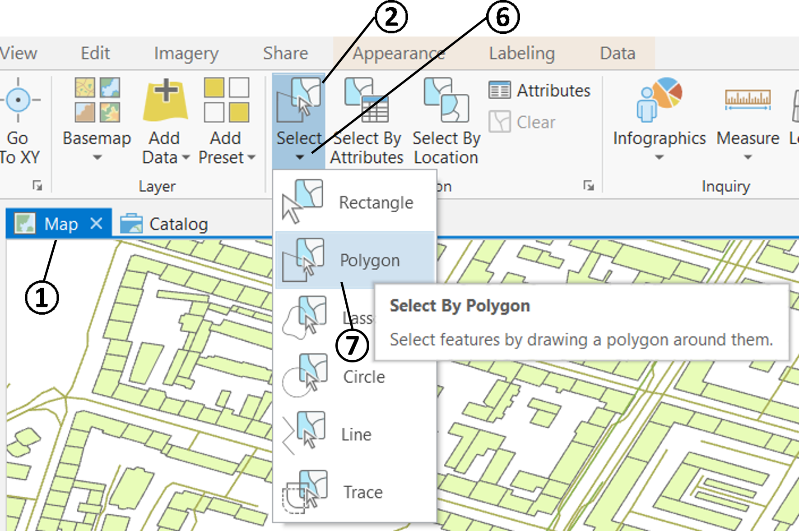

1. CLICK into the *Map* view to select the Old Pinakothek building. A cyan contour should appear around the polygon.
2. Hold down the SHIFT-KEY and CLICK more building polygons to add to the current selection
3. Deselect the current selection by either CLICKING on the Clear button  in the Selection space or CLICKING into empty space (white space with no geodata) on the Map view.

* CLICK on the Select dropdown arrow to view the different interactive selection options.
* CLICK on the Polygon option.

1. CLICK onto three corners of the TUM building block (on the map) to create the vertices of the polygon. Double-click to close the polygon and select all TUM building parts.

As you interactively select features by clicking or digitizing a shape on the map, the number of features selected is displayed at the bottom of the view. Zoom to the extent of the selected features by clicking the *Selected Features* count.

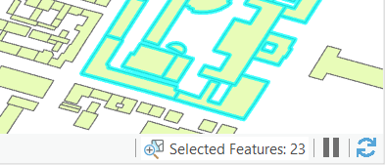

* Press *Shift* and hold to add features to an existing selection. You can click individual features or digitize around a collection.
* Press *Ctrl* and hold to remove one or more features from the existing selection.
* Press *Ctrl + Shift* and hold to select from the current selection and deselect all others.

## SELECTING BY LOCATION

The *Select By Location* tool allows you to select features based on their location relative to features in another layer.

* Select all cafes around the TUM building in a 500-meter radius.

1. Check if the TUM buildings are still selected (TUM buildings only). Otherwise, repeat from 1.6 No. 6.
2. CLICK on *Select By Location* button  which is found on the **Map** tab in the *Selection* group. The **Select By Location** dialog box opens.

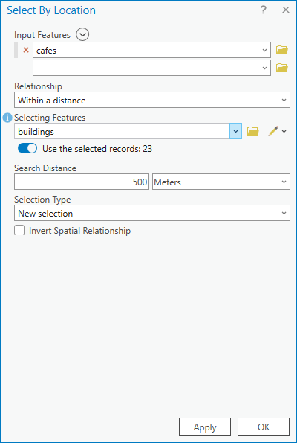

* Choose the *cafes* layer as *Input Features* using the dropdown arrow. (The selection will be applied to the input features.)
* Set the *Relationship* to *Within a Distance*. The features in the input layer will be selected if they are within the specified distance (using Euclidean distance) of a selecting feature.
* The *Selecting Features* must be the *buildings* layer*.* The to be selected features will be selected based on their relationship to the features from the *buildings* layer. In this case, only the TUM buildings, rather than all the features in the *buildings* layer are considered, so only *use the selected records* (the selected TUM buildings in Step 1).
* The *Search Distance* can be set reasonably. In this case, it’s suggested to be set as *500 Meters*.
* Define a *New selection* as *Selection Type.*
* Execute the tool by clicking on *Apply* (the window will stay)or *OK* (the window will be closed)*.* (If hidden, make the *cafes* layer visible to view the selection results.)

## SELECTING BY ATTRIBUTES

ArcGIS Pro uses (like other GIS) a relational data model and can therefore be called a Database Management System (DBMS). The here applied geodatabase storage model is based on DBMS principles, leveraging a series of simple yet essential relational database concepts.

Key concepts include the following:

* Data is organized into tables with columns and rows
* SQL queries can be applied to the data.

The *Select By Attributes* button Select By Attributes opens the *Select By Attributes* geoprocessing tool to form an SQL query to select features matching a selection criteria. So, instead of interactively selecting features by clicking or drawing a graphic in the map or scene, you build a query expression to generate the subset. You can query a dataset based on a field in a layer or a table.

* Select all tram lines of the *railways* layer by selecting the correct attributes. Copy these selected features into a separate layer.

1. Add the *railways* layer from *Data Students.gdb*. (add data like in 1.3)
2. RIGHT-CLICK the railways layer in the Contents pane and CLICK *Attribute Table* Open Table. Get an overview of the existing attribute fields we can address.

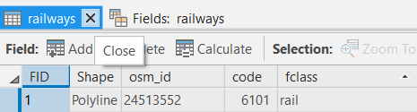

Close the attribute table by CLICKING on close .

1. CLICK on *Select By Attributes* button 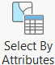 which is found on the **Map** tab in the *Selection* group. The **Select By Attributes** dialog box opens.

* Choose the *railways* layer as *Input Rows* using the dropdown arrow.
* Define a *New selection* as *Selection type.*

1. Add a new expression by CLICKING on *Add Clause* *.*

* Using the dropdown arrow menu, set the clause to “*Where fclass is equal to tram*”.
* Execute the tool by clicking on *Apply* or *OK.*

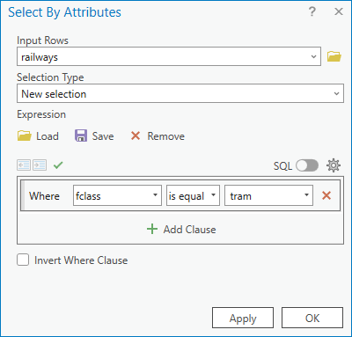

* With the *Select By Attributes* tool you can optionally make a SQL expression instead of adding clauses. Any clauses can also be viewed as SQL expressions by switching to *SQL*.

1. On the status bar, at the bottom of Your programme window, check the number of selected features. Zoom on to selected features by CLICKING either here on *Selected Features*  or in the *Navigate Group* on the *Map* tab.
2. RIGHT-CLICK on the *railways* layer in the *Contents* pane and CLICK on *Selection >* *Make Layer From Selected Features.* A layer named “*railways selection*” will appear in the *Contents* pane.
3. Rename the new layer to “*tram\_lines*” by CLICKING TWICE, or by DOUBLE CLICKING or RIGHT-CLICKING on the layer in the *Contents* pane and going to *Properties*. Under *General*, you can change the *Name* entry.

* Using the same workflow, select all underground lines by selecting the attribute *subway*. Copy these selected features into a layer named *underground\_lines*.

## FIELDS

Tables form the foundation of GIS and are the fundamental building blocks of all rational data models. Tables are a collection of information in rows and columns, such as a list of building owners, employees, or customer information. Layers in a map, such as city streets, buildings, or address points, are simply tables that include information about the geometry and location of those features.

Tabular information consists of rows and columns, with all rows having the same columns. In ArcGIS, rows are known as records and columns are referred to as fields. Each field in a table can store a specific type of data, such as a number, date, or piece of text. So, fields form the attribute information for any given layer in the map or stand-alone table. Each field has a type, such as integer, decimal number, character, date, and so on.

### Renaming Fields

In ArcGIS Pro, you can view and manage the fields of a layer or table in the fields view. This allows you to model the attributes that are shared by a collection of features or objects in a table. Within the fields view you can edit the fields and their properties, delete fields, and create new ones.

The task is to rename a field (column) of the *roads* attribute table for better understanding. Furthermore, important fields are to be highlighted. Dispensable fields are to be hidden from view in order to gain a higher clarity for following analysis tasks.



1. To open the fields view, highlight (that is, click) the layer *roads* whose fields you'd like to view in the *Contents* pane. This displays the *Feature Layer* tabs.
2. CLICKING the *Data* tab, you will find the Data Design group containing icons for Fields, Subtypes, and Domains. These are your tools for working with a data model.

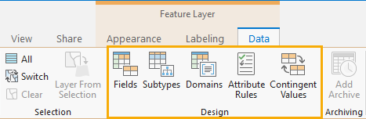

1. CLICKING the *Fields* button opens the *fields view*, displaying the layer's fields in a tabular arrangement. You now see the fields from that layer and columns to display the properties of those fields
2. DOUBLE-CLICK onto the *Field Name* “*highway*”. Rename it to “*type*” and rename the Alias to “*type of road”.* This makes the specification of this field more understandable.
3. CLICK the *Highlight* check-box of the *type* filed, to emphasize it in the attribute table view.
4. Deselect first the Visibility of all fields by CLICKING on the *Visible* check-box on the top-left of the fields view. Then, reselect the fields “OBJECTID”, “*type*”, “*name*”, “*maxspeed*” and “*oneway*”. The other fields will not be needed in the coming lessons.

1. CLICK on Save , which You find on the *Fields* tab in the *Manage Edits* group. The changes have now been applied to the attribute table of this layer.
2. CLICK  to close the Fields view.
3. Open the attribute Table by CLICKING on the Attribute Table Symbol A white and blue square with black text

   Description automatically generated.

### Converting a String Field to a Numeric Field

Workflow_icon All OSM tags (of the original data set) are imported as strings (text), even when the field information could be numeric. For future numeric calculations and quantitative analysis some string fields are to be converted into numeric fields.

1. RIGHT-CLICK the *roads* layer in the *Contents* pane and CLICK *Attribute Table* Open Table.
2. CLICK the *Add* buttonto create a new field. The Fields View is automatically opened.

* The *fields view* is used to manage the fields of a layer or table. Within the *fields* view you can view, edit, and delete fields as well as create new fields.
* Another way of getting to the *Fields View* is byCLICKING the hamburger icon  in the upper right corner of the attribute table and CLICKING *Fields View.*

1. In the Fields list view, set the following properties
   * Set the name *speed\_num* for the new field.
   * Set the *Data Type* to a numeric type. *Long* is fine.
   * Set the *Number Format* to *Numeric*.
2. Save the edits to the table (like in 1.9.1), and close the *Fields view.*
3. RIGHT-CLICK the header of the newly created numeric field *speed\_num* and select *Calculate Field*. The **Calculate Field** geoprocessing dialog box opens.
4. The *Input Table, Field Name*, and *Expression Type* are automatically filled. In the *Expression Fields* list window, find and DOUBLE-CLICK the string field *maxspeed*. The expression is quite simple, with the string field name put into exclamation marks. The following must be entered in the *Expression* text box: !maxspeed!
5. CLICK *Apply* or *OK* to execute the command. All values are transferred as numeric values into the new field.

* You will receive a warning-message from the programme, because empty fields could not be transferred to the new fields. This does not matter at this point.

## CREATING A NEW FEATURE CLASS

Feature classes are homogeneous collections of common features, each having the same spatial representation and a common set of attributes. The four most commonly used feature classes are the three geometrical primitives in points, lines, polygons, as well as annotations.

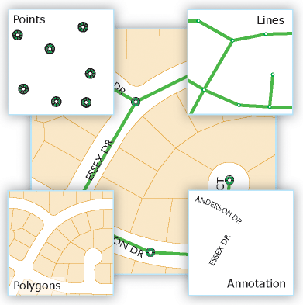

You work with feature classes in ArcGIS Pro in a similar way to working with shapefiles. They can be added to the map as a layer. ArcGIS Pro gives you a little more editing freedom with feature classes than with shapefiles.

You can create new feature classes by using the Create Feature Class tool. When you create a new feature class, you must define the types of features it will contain and whether those features will be three-dimensional (z-values). These properties can't be modified after the feature classes have been created.

Workflow_icon Create a new polygon feature class named *Lawn*.

1. Open the *Catalog* pane by CLICKING *View > Catalog pane* 
2. In the *Catalog* pane, extend *Databases* and RIGHTCLICK on your geodatabase (the one with the same name as your project name).

* HOVER OVER *New*
* And CLICK *Feature Class.*

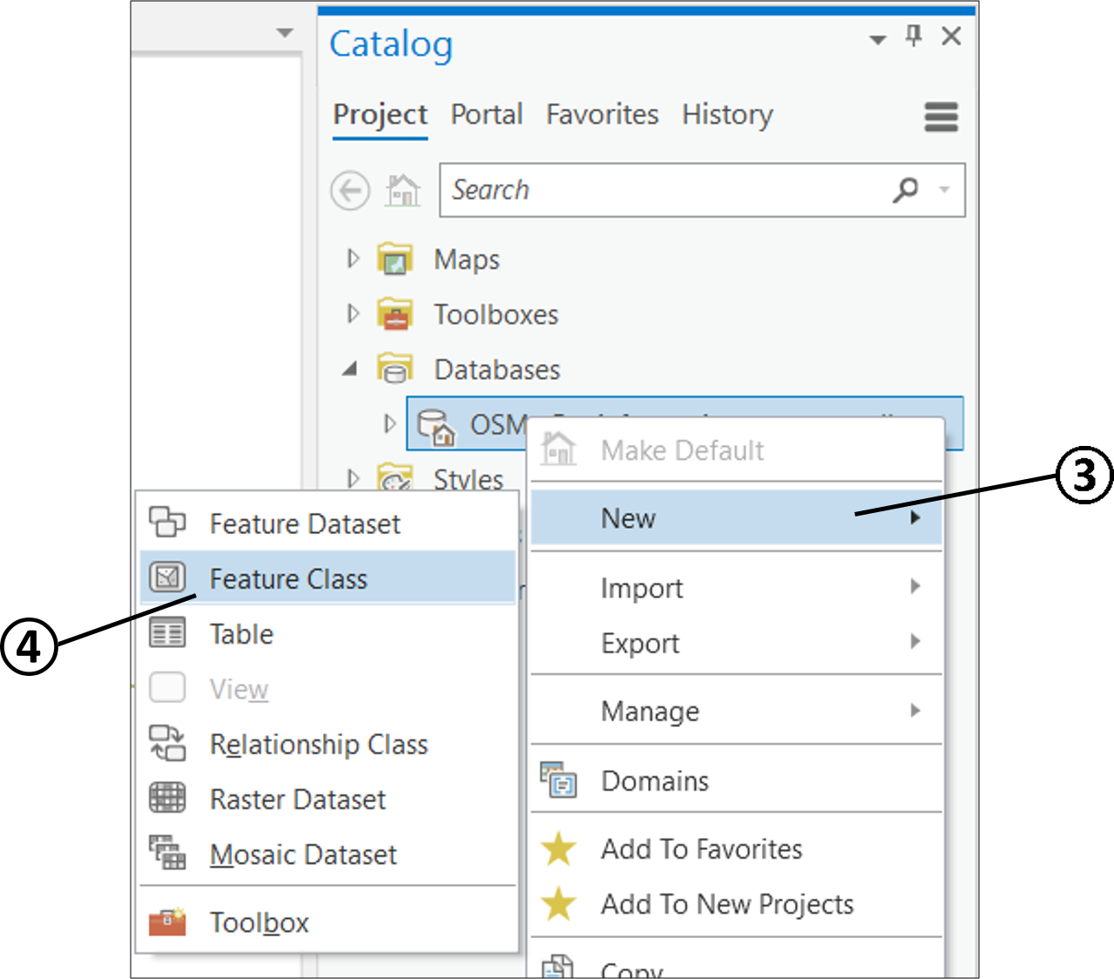

1. On the **Define** page of the opened wizard pane, type a *Lawn* for the feature class in the *Name* text box. To create an alias for this feature class, type *Lawn areas* into the *Alias* text box.
2. Select *Polygon* as *Feature Class Type* using the dropdown menu.
3. UNCHECK the *M and Z Values* of the *Geometric Properties* (we do not need these yet) and CLICK *Next*
4. In the **Fields** step, you could create new attributes as columns in the attribute table. Please skip this step by CLICKING *Next.*
5. WGS 84 is preselected on the **Spatial Reference** page. This is the coordinate system of the other used data. Leave the pre-selections unchanged and go to the next step by CLICKING *Next.*
6. Use the default values of the next three pages Tolerance, Resolution and Storage Configuration by CLICKING *Next,* CLICKING *Next and* CLICKING *Finish.*

## EDITING NEW FEATURES

* Add now the new Feature Class *Lawn* to the Map and then create a new lawn polygon around the Old Pinakothek. Use the orthophoto to make a simple rectangle polygon.

1. Expand your database by CLICKING on the unfilled arrow besides your geodatabase on the *Catalog* pane.

* If the feature class *Lawn* is not already added to the *Contents*, DRAG the feature class *Lawn* onto the *Map* space to add it to the *Contents.* (It should be already there, if “Add output dataset to current map” is selected when you Create Feature Class.)

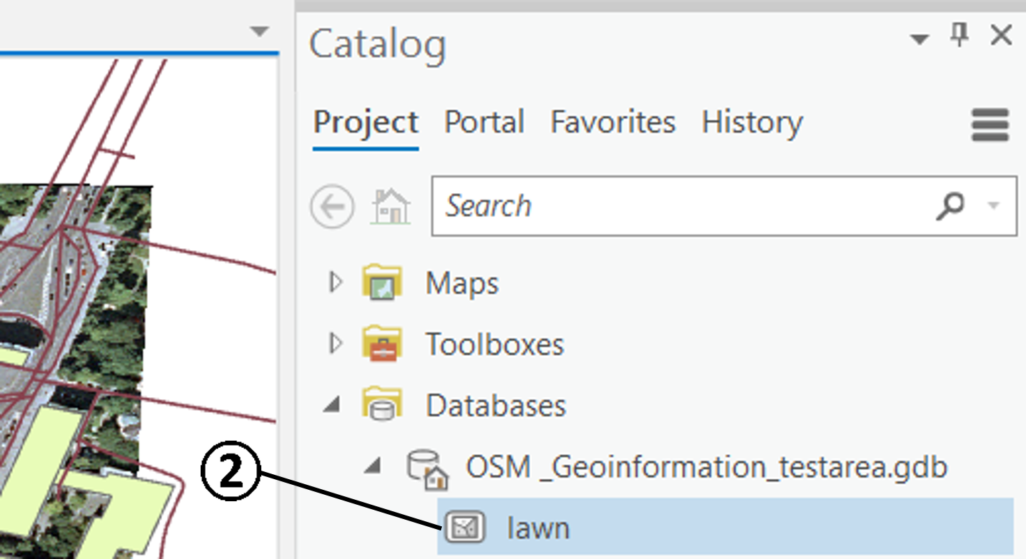

1. Go to the *Edit* tab on the ribbon and CLICK *Create*  among the *Features.* The *Create Features* Panewill open.
2. CLICK on the *Lawn areas*, more editing functions are shown.

* CLICK on the polygon symbol to activate the polygon creating function.

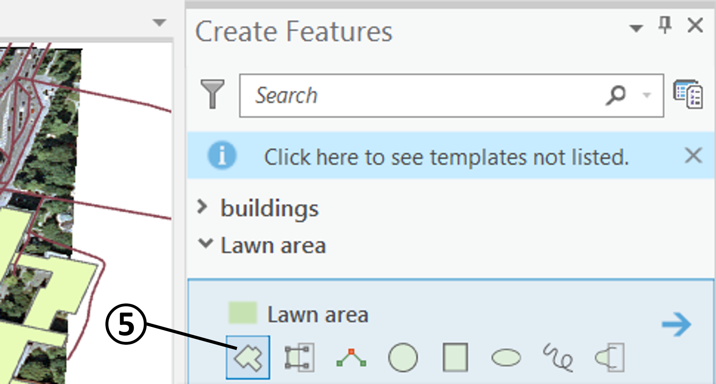

1. Make a rectangle around the Old Pinakothek by CLICKING in three corners and finish the digitizing by DOUBLE-CLICKING into the fourth corner.
2. Save the new drawn polygon by CLICKING on *Save*  on the *Manage Edits* group of the Edit tab.
3. CLICK on  and CLOSE the *Create Features* Pane to stop the editing.
4. In the *Contents* pane, DRAG the *Lawn* layer under the *buildings* layer to not occlude the Old Pinakothek building.

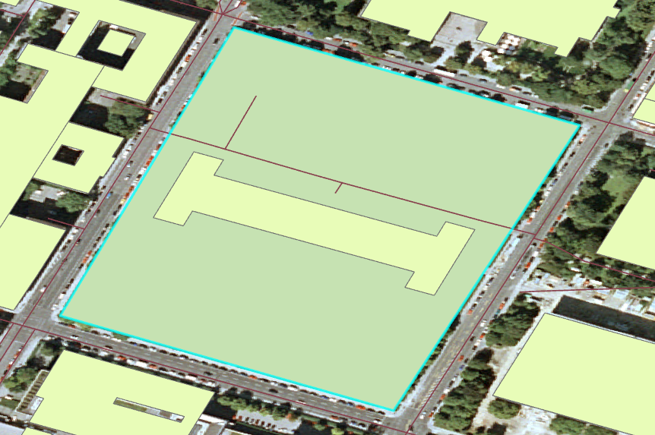

### Create New Tram Stops and Underground Stations

In this section we want to enrich the information on trams and the underground in our data set. The task will be to digitize tram stops and the underground stations as point features.

Create two new point feature classes using the same workflow as in 1.10. Name one *tram\_stops* and the other *underground\_stations*. Select this time *Point* as *Feature Class Type* on the *Define* page.



Workflow_icon Edit new point features using the same workflow as in 1.10 and 1.11. Refer to the following image from the MVG (Münchner Verkehrsgesellschaft / Munich Transport Company) to create the tram stops: Pinakotheken, Karolinenplatz, and Ottostr. along the Barer Straße on tram line 27/28 (see the following figure). Create one point feature per tram stop.

Edit the underground stations, too. Refer to the image from the MVG to create the underground stations of the study area. Create one point feature per underground station.



* Please double-check that the features you’re creating are the features you want to create in order to avoid situations like creating underground stations in the tram\_stops feature class.

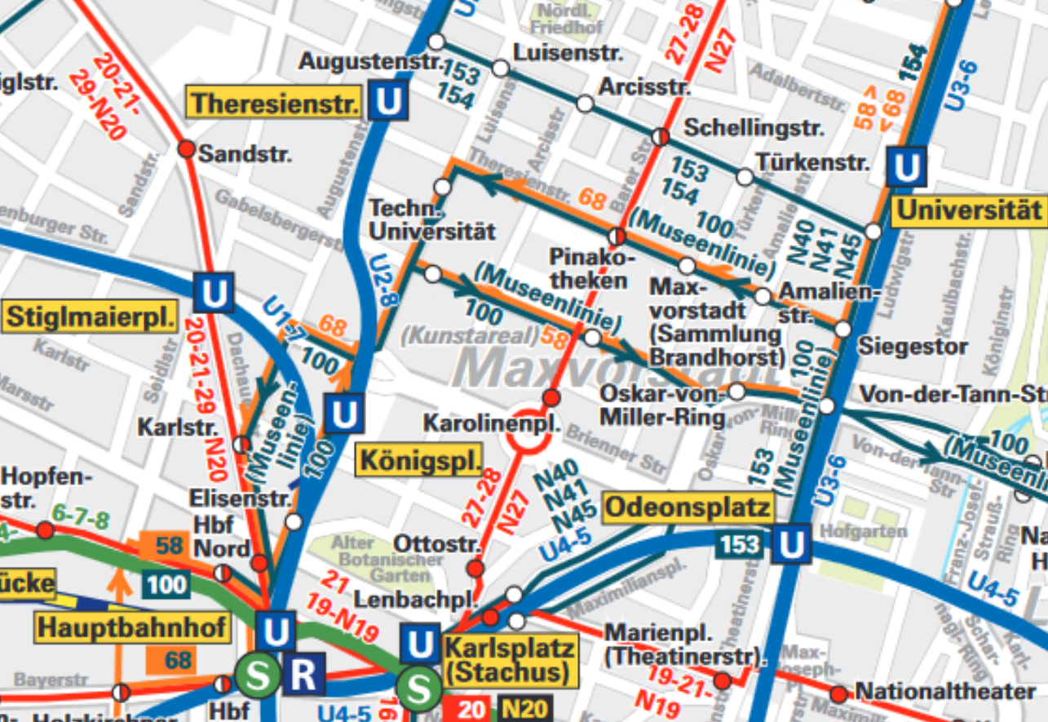

### Creating a New Template for Editing

* Sometimes, the to be edited feature does not appear in the templates list on the *Create Features* pane. First, check if the visibility of the layer is toggled on, on the *Contents* pane. If it still doesn’t appear, then you need to create a new template. In this case, perform the following workflow:

1. CLICK next to the *search* option in the *Create Features* pane to Manage Templates.
2. CLICK on the *New* New Template expansion dropdown arrow.
3. CLICK on *Template…* to open **Template Properties**.
4. CLICK *General*(if not done already).
5. In the *Name* text box, type a name (i.e. *buildings)* for the new template.
6. In the *Description* text box, you can document the template with an optional description that you and your organization can search and find in the pane. In the *Tags* text box, the keyword for the geometry type is automatically generated. You can delete it or add additional tags. These are not needed for this task.
7. CLICK *OK.*
8. Close *Manage Templates* to go back to the *Create Features* pane. The intended layers of the template should appear in the list.

## EDITING ATTRIBUTES

Workflow_icon In this section we want to enter more attribute information to the tram stops and the underground stations. We will also harmonise some attributes of the TUM buildings by calculation. You will learn how to add fields and learn two different ways of editing attributes.

### Adding New Fields to the Attribute Table

1. Open the attribute table as in previous tasks. For instance, by RIGHT-CLICKING the layer *trams\_stops* in the Contents pane and clicking *Attribute Table*.
2. CLICK on *Add*  to add a new field (attribute column). The *Field View* tab becomes active

* TYPE *name* as the new field name.
* DOUBLE-CLICK on its *Data Type* value (*Long*). Choose *Text* from the appearing dropdown-arrow.

1. CLICK on Save , which You find on the *Fields* tab in the *Manage Edits group*. The new field has now been added to the attribute table of this layer.
2. Repeat steps 1 to 5 for the layer *underground\_stations*.

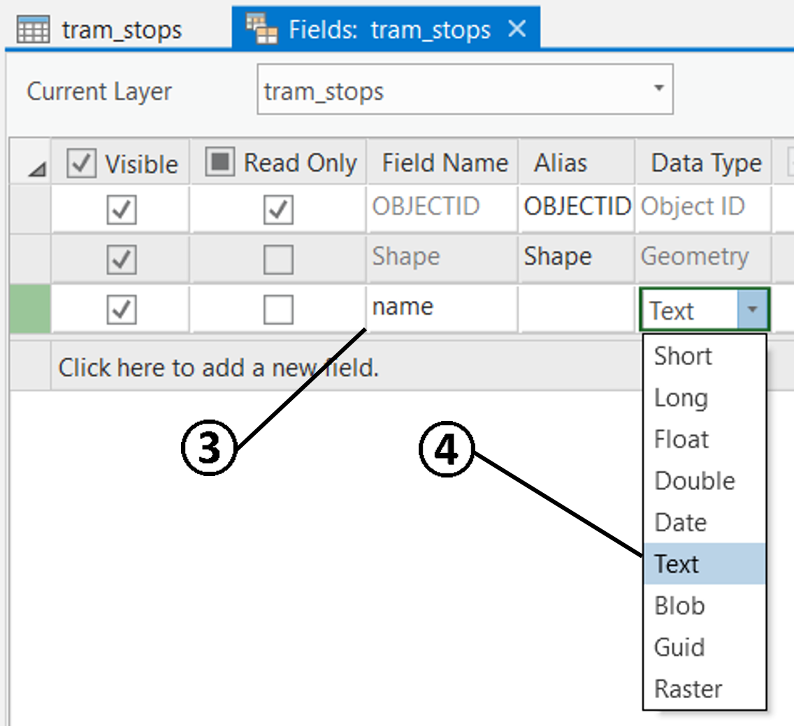

### Editing the Fields of the Attribute Table

**First way:**

1. Close the *Fields: tram\_stops* and *Fields: underground\_stations* tabs, keep both of the Attribute Tables.
2. Get into the interactive selection mode by CLICKING on a *Select* button .
3. Select an object by CLICKING on the row of the *tram\_stops* attribute table. Check which stop is selected. The selected one has a cyan halo.
4. Assign a tram stop name by DOUBLE-CLICKING on the required field of the Attribute table and TYPING in the correct tram stop name. Check the MVG plan in section 1.11.1 for correct naming.
5. Perform the naming for the other rows of the attribute table.
6. CLICK *Save*  on the *Edit* tab to save all edits.

**Second way:**

In the *Attributes* pane, you can identify features and edit attributes stored in the feature attribute table or a related table.

Editing feature attributes in the attributes pane enables you to select and edit features on multiple layers without opening the attribute table. You can set the pane to automatically apply your changes as you enter them or wait until you click to apply them.

1. CLICK *Attributes* Attributes on the *Selection group* of the **Edit** tab. The Attributes pane will open.
2. CLICK to select an underground station point on the map.
3. You will find the corresponding name field under Attributes on the Attributes pane. CLICK to activate it, TYPE in the correct name, CLICK the ENTER key on your keyboard, and CLICK Apply to save it (you can also turn on Auto Apply).
4. Perform the naming for the other underground stations.
5. CLICK *Save*  on the *Edit* tab to save all edits.

* Fields that are managed by attribute rules restrict your changes to values defined by the rule. When your edits violate a rule, a notification appears in the pane, informing you of the rule that is preventing your changes.

### Calculating the Fields of the Attribute Table

You can use field calculations to create an expression to perform simple or complex calculations on your field values in a table. You may want to perform a mathematical calculation on a set of field values for a single record or all records. Performing field calculations is a way to batch update many records in your table at once. Field calculations work on string, number, and date fields, and automatically calculate selected records if the layer or table has a selection set present.

1. Select the TUM building polygons. You can choose a method to select the buildings of the TUM. You can do this according to chapter 1.6.
2. CLICK to select the *buildings* layer on the *Contents* pane.
3. RIGHT-CLICK on the layer *buildings* in the Contents pane and CLICK *Attribute Table.*
4. CLICK on the *Calculate* button . The **Calculate Field** dialog box opens.
5. Make sure to turn on “Use the selected records”. Use the *Field Name* dropdown arrow to choose the attribute column *amenity.*
6. Choose *Python* as the Expression Type.

1. TYPE in "TUM" into the *amenity=* text field.
2. CLICK *Apply* or *OK* to perform the simple calculation. The *amenity* field of the selected records should state *“TUM”.*

* If the *Calculate Field* command is unavailable, consider the following possibilities:
* A field that is managed by ArcGIS cannot be edited manually. Consequently, you cannot calculate field values for the ObjectID (OID or FID) field or the Shape\_Length and Shape\_Area fields for a geodatabase feature class.
* The table's data source is read-only, write access can't be established to the folder or geodatabase, or the data source is in a format that can't normally be modified.
* The field belongs to a table that has been joined to your table. You can only calculate values for fields in the origin table.
* The field may be a raster, BLOB, or Global ID type, which cannot be calculated.

### Combining Editing Skills

Copying attribute values from one field to another may fail in ArcGIS Pro, if there are too many empty ‘no data’ values. In this section we learn a way to overcome this problem.

Workflow_icon The general task is to create a field for the buildings that features a numerical value for the number of building levels.

* Select the buildings without a building level entry and fill their records with the text “no data”. (This way we have text records and no empty records.)

1. RIGHT-CLICK the *buildings* layer in the *Contents* pane and CLICK *Attribute Table* Open Table.
2. Select the no-data values of the field *building\_l* by *Selecting by Attributes* (see 1.8). Set the clause to “*Where building\_l is equal \_\_\_\_\_\_*”. Make sure only these buildings are selected.
3. CLICK on the *Calculate* button . The **Calculate Field** dialog box opens.
4. Use the *Field Name* dropdown arrow to choose the attribute column *building\_l.*
5. Choose *Python* as expression type.
6. TYPE in “no data” into the *building\_l =* text field.
7. CLICK *Apply* or *OK* to perform the simple calculation on the selected records. These (only) should state *“no data”.*

* Convert the string *building\_l* field of the *buildings* layer into an added numeric field named *level\_num.* This new field will feature the number of building levels.

1. RIGHT-CLICK the *buildings* layer in the *Contents* pane and CLICK *Attribute Table* Open Table.
2. CLICK the *Add button* to create a new field. The Fields View is automatically opened.

* If you cannot add a field, it may be because You have an unfinished editing session. In that case save your edits prior to adding a new field.

1. In the Fields list view, set the following properties
   * Set the name *level\_num* for the new field.
   * Set the *Data Type* to a numeric type. *Long* is fine.
   * Set the *Number Format* to *Numeric*.
2. Save the edits to the table (like in 1.9.1), and close the *Fields view.*
3. RIGHT-CLICK the header of the newly created numeric field *level\_num* and select *Calculate Field*. The **Calculate Field** dialog box opens.
4. The *Input Table, Field Name*, and *Expression Type* are automatically filled. In the *Expression Fields* list window, find and DOUBLE-CLICK the string field *building\_l*. The *Expression* text box should be the following: !building\_l!
5. CLICK *Apply* or *OK* to execute the command. All values are transferred as numeric values into the new field.

* Records with the text “no data” will not be converted to a numerical value. These remain as no data values which are shown as *<Null>.*

Contents

[Lesson 1 – Selecting and Editing Features 1](#_Toc165369247)

[1.1 DESCRIPTION 1](#_Toc165369248)

[1.2 CREATING A NEW PROJECT 1](#_Toc165369249)

[1.2.1 Connecting a Folder to the Project 3](#_Toc165369250)

[1.2.2 Add a Database 4](#_Toc165369251)

[1.3 ADDING A LAYER TO THE MAP 4](#_Toc165369252)

[1.4 ADD AN IMAGE LAYER TO THE MAP 6](#_Toc165369253)

[1.5 USING POP-UPS IN ArcGIS Pro 6](#_Toc165369254)

[1.6 SELECTING FEATURES INTERACTIVELY 7](#_Toc165369255)

[1.7 SELECTING BY LOCATION 8](#_Toc165369256)

[1.8 SELECTING BY ATTRIBUTES 9](#_Toc165369257)

[1.9 FIELDS 11](#_Toc165369258)

[1.9.1 Renaming Fields 12](#_Toc165369259)

[1.9.2 Converting a String Field to a Numeric Field 13](#_Toc165369260)

[1.10 CREATING A NEW FEATURE CLASS 14](#_Toc165369261)

[1.11 EDITING NEW FEATURES 16](#_Toc165369262)

[1.11.1 Create New Tram Stops and Underground Stations 17](#_Toc165369263)

[1.11.2 Creating a New Template for Editing 18](#_Toc165369264)

[1.12 EDITING ATTRIBUTES 19](#_Toc165369265)

[1.12.1 Adding New Fields to the Attribute Table 19](#_Toc165369266)

[1.12.2 Editing the Fields of the Attribute Table 20](#_Toc165369267)

[1.12.3 Calculating the Fields of the Attribute Table 21](#_Toc165369268)

[1.12.4 Combining Editing Skills 22](#_Toc165369269)